Program 1: Design and Implementation of a 4-to-2 Encoder Using VHDL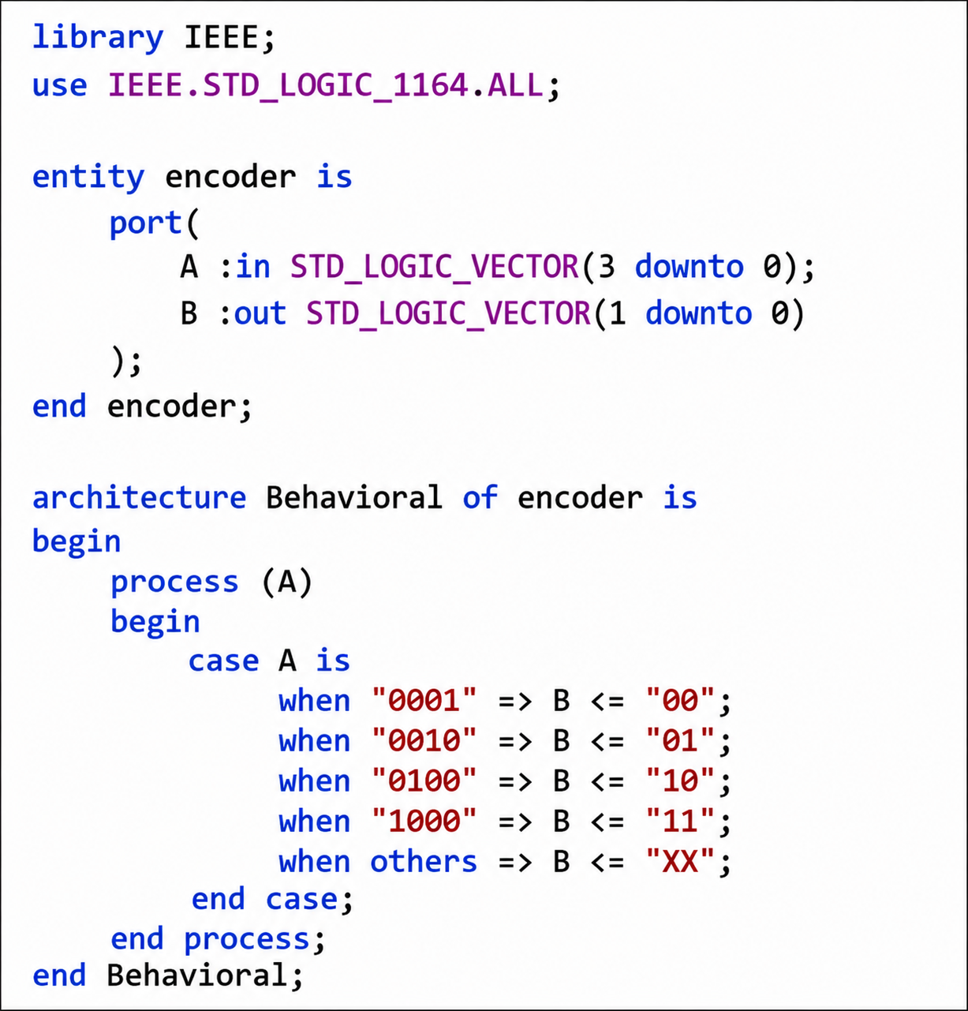
Program 2: Design and Implementation of a 2-to-4 Decoder Using VHDL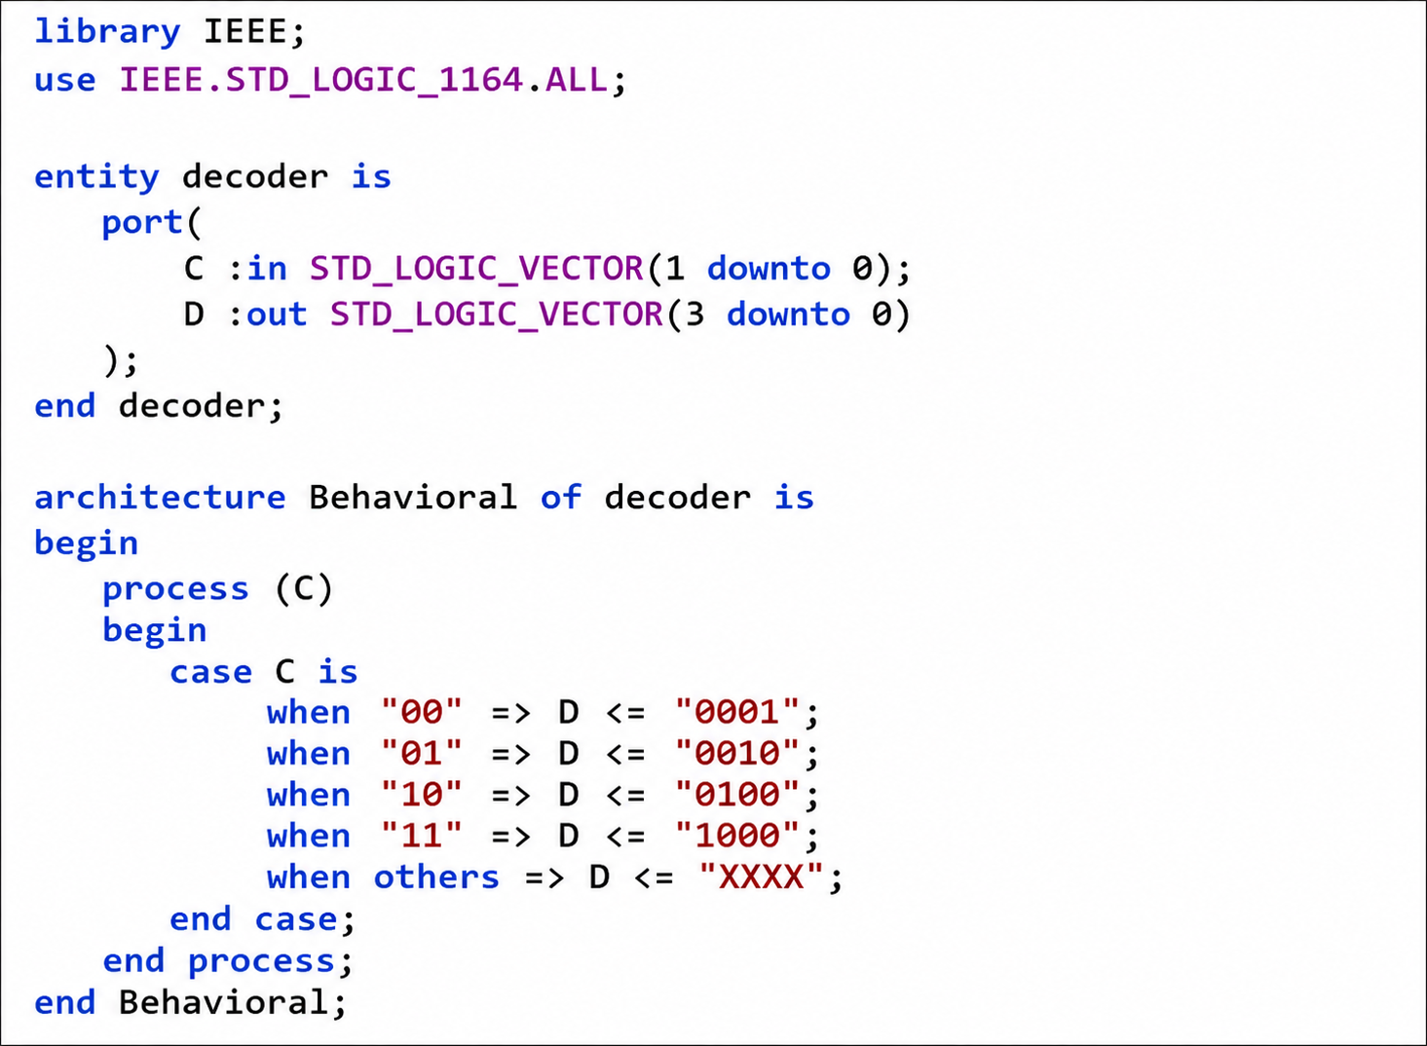

Figure 1: VHDL Code for 4-to-2 Encoder
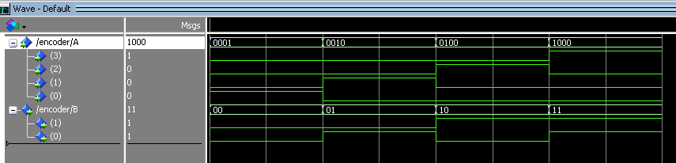
Figure 2: VHDL Code for 2-to-4 Decoder
